**Scope**

This custom project will include a custom GS Mobile transaction that will allow shop floor staff to scan barcode labor step on WO router label to process a labor transaction that back-flushes both material (as indicated in the router) and labor based on router operation estimate of 1 piece. It will also include a customized WO/inventory label to scan as it moves through the steps on the router and then become the inventory label for finished goods. This label will be formatted as a 4x6 portrait layout.

**Installation**

1. Unzip GAB_Mobile_Labor_BF.zip to global\plugins\gab\gas
2. Save mobile_custom_result.sql to global\scripts
3. Save SF_BarcodeWO-Ext_FiberFab.rpt to global\busint\custom
4. Save serial_label.rpt to global\busint\custom
5. Create new custom mobile transaction (advanced GS mobile options > Custom)
   1. take note of transaction id number (1-5)
   2. name "Fiber-Fab Labor"
   3. add 2 new labels (fields) on web form set as textbox
      1. Operations (JSS) (set to field length to 17)
      2. Employee (set field length to 7)

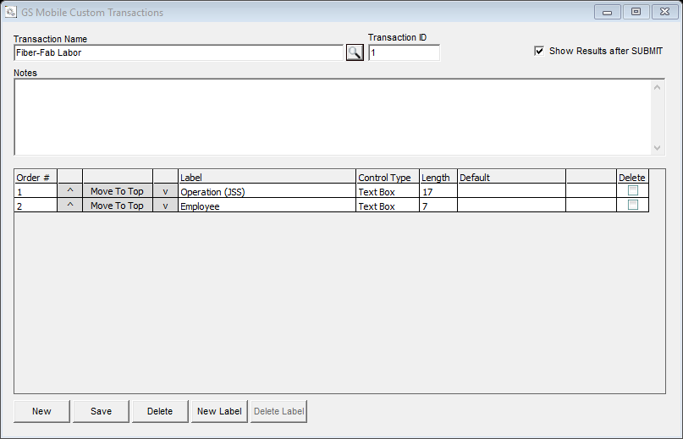

* 1. check box to "show results after SUBMIT"
  2. save

1. Run mobile_custom_result.sql in globalcommon DB
   1. Start > run > pcc
   2. File > open > global\scripts\mobile_custom_result.sql
   3. Select Globalcommon DB
   4. Select <F9> to execute
2. Activate GAB hook (system support > administration > gab script hook maintenance)
   1. if custom transaction id is 1 then GAB hook to activate is 39001, if it is 2 then hook is 39001 and so forth
   2. Enter hook id then select to <Add Seq>, browse for global\plugins\gab\gas\ GAB_Mobile_labor_BF.gas, Save Seq, Save Hook.
   3. Stop and restart wirepoll.exe
3. Grant mobile user access to the new custom transaction (system support > administration > GS Mobile Users > Open)
4. Activate custom barcode WO report
   1. Business Intelligence > Administration > Report Maintenance
   2. Active new report sequence for report id 1811 pointing to network UNC path to custom report
5. Create new custom BI report and link serial_label.rpt to new report ID.

Validation/Filter

* 1. Operation (JSS)
     1. Validate labor step is not closed
     2. Validate previous labor step is closed
  2. Validate employee number:
     1. Validate employee number either entered in mobile form or found in lookup to employee master where work center on scanned labor step matches value in comment 1.

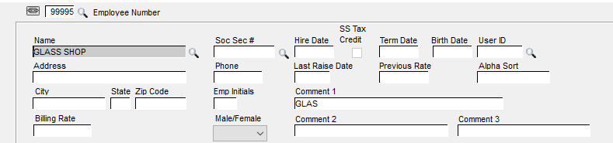Payroll > File > Employees > Open

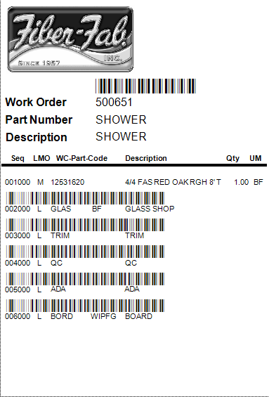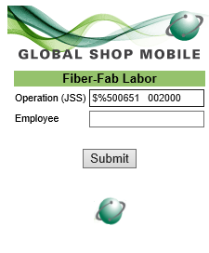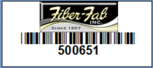

**Using Transaction**

Assumptions

* Labor transaction will be processed through assuming 1 good piece reported and labor step will be closed
* Backflush hours for operation based on estimate in the WO router
* Material will backflush according to backflush setup for op code such as ‘BF’
* WO will auto WIP to FG if op code on the last labor step is set to ‘WIPFG’ or similar

Data Entry

* Operation (JSS) – Scan operation barcode from WO label
* Employee – Scan employee badge or leave blank if using WC employee # setup and cross referenced

**Return Results Page**

* Every transaction will be validated with a message stating transaction was successful or failed and why.

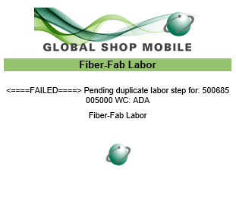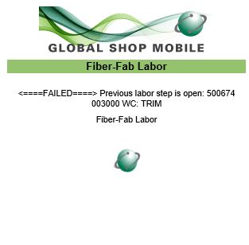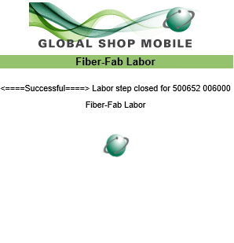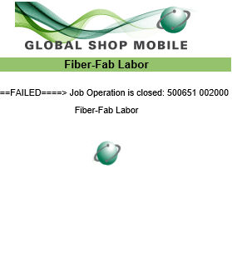

Result of successful transaction

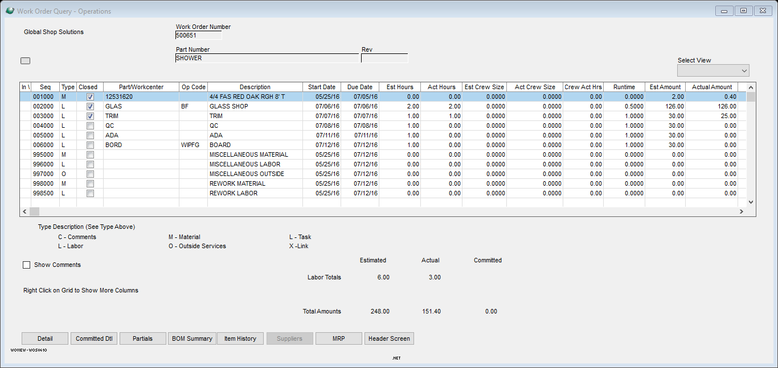



* Serial Label will print when WC on labor step = BRDS
  + Label printers to default label printer assigned to GS Mobile user